Unit 4

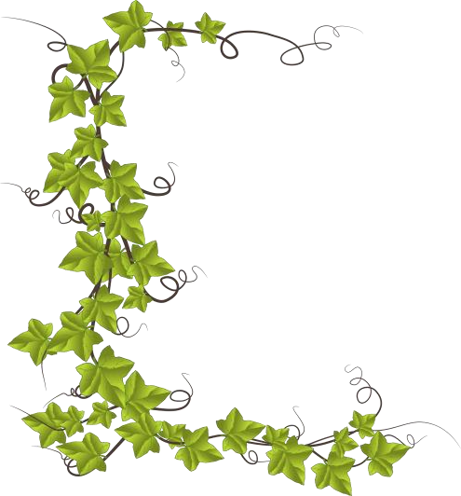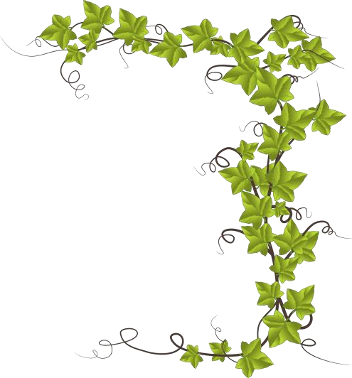Robin Hood by H. E. Marshall
Unit 4

It happened on a bright sunshiny day in early spring. All through the winter Robin and his men had had a very dull time. Nearly all their fun and adventures happened with people travelling through the forest. As there were no trains, people had to travel on horseback. In winter the roads were bad, and the weather so cold and wet, that most people stayed at home. So it was rather a quiet time for Robin and his men. They lived in great caves during the winter, and spent their time making stores of bows and arrows, and mending their boots and clothes.

Robin Hood – extract

This bright sunshiny morning Robin felt dull and restless, so he took his bow and arrows, and started off through the forest in search of adventure.
He wandered on for some time without meeting any one. Presently he came to a river. It was wide and deep, swollen by the winter rains. It was crossed by a very slender, shaky bridge, so narrow, that if two people tried to pass each other on it, one would certainly fall into the water.
Robin began to cross the bridge, before he noticed that a great, tall man, the very tallest man he had ever seen, was crossing too from the other side.
“Go back and wait until I have come over,” he called out as soon as he noticed the stranger. The stranger laughed, and called out in reply, “I have as good a right to the bridge as you. You can go back till I get across.”
This made Robin very angry. He was so accustomed to being obeyed that he was very much astonished too. Between anger and astonishment he hardly knew what he did.
He drew an arrow from his quiver, and fitting it to his bow, called out again, “If you don’t go back I’ll shoot.”

Robin Hood by H. E. Marshall

“If you do, I’ll beat you till you are black and blue,” replied the stranger.
“You talk like an ass,” said Robin Hood.
“If I talk like an ass you talk like a coward,” replied the stranger. “Do you call it fair to stand with your bow and arrow ready to shoot at me when I have only a stick to defend myself with? I tell you, you are a coward. You are afraid of the beating I would give you.”
Robin was not a coward, and he was not afraid. So he threw his bow and arrows on the bank behind him.
“You are a big, boastful bully,” he said. “Just wait there until I get a stick. I hope I may give you as good a beating as you deserve.”
The stranger laughed. “I won’t run away; don’t be afraid,” he said.
Robin Hood stepped to a thicket of trees and cut himself a good, thick oak stick. While he was doing this, he looked at the stranger, and saw that he was not only taller but much stronger than himself.

Back he came with a fine big stick in his hand and a smile on his face. The idea of a real good fight had made his bad temper fly away, for, like King Richard, Robin Hood was rather fond of a fight.
“We will fight on the bridge,” said he, “and

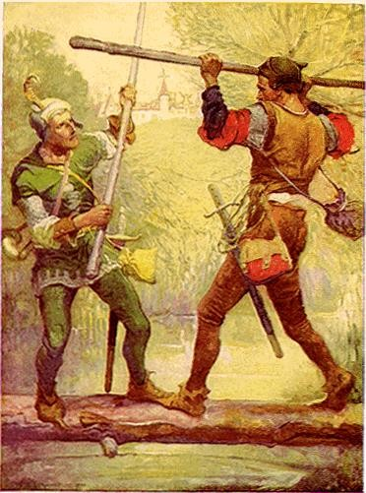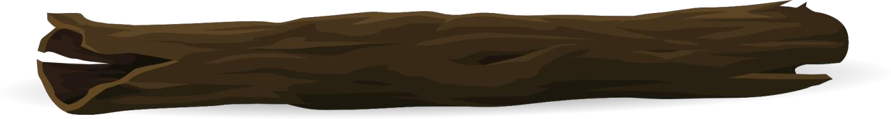However, that did not frighten Robin in the least. He was rather glad of it indeed. The stranger had said he was a coward. He meant to prove to him that he was not.
Unit 4
whoever first falls into the river has lost the battle.”
“All right,” said the stranger. “Whatever you like. I’m not afraid.”

Unit 4

Robin Hood by H. E. Marshall

Comprehension questions

Name: ............................................................... Date:..................................................................

- Name two reasons why people did not travel through the forest in winter.

1. .......................................................................................................................................

2. .......................................................................................................................................

- How did Robin and his men spend their time in winter? Name one activity.

...................................................................................................................................................

- Look at the paragraph which begins: ‘He wandered on …’
Find and copy a word which means unsteady.

...................................................................................................................................................

- Why was Robin astonished when the stranger told him to go back?

...................................................................................................................................................

‘You are a big, boastful bully …’
Circle the word closest in meaning to boastful.

unkind | ugly | bragging | frightening

- Why does the stranger think that Robin is being unfair?

...................................................................................................................................................

‘Robin Hood was rather fond of a fight.’
Explain in your own words what this means.

...................................................................................................................................................

...................................................................................................................................................

Unit 4

Robin Hood by H. E. Marshall
- Put the following events in order. The first one has been done for you:

 |  | Robin went off through the forest in search of adventure.
 |  | The stranger agrees to fight on the bridge.
 |  | Robin threatens to shoot the stranger with his bow and arrow.
1 |  | Robin and his men lived in caves during the winter.
 |  | A tall man begins to cross the bridge.
Unit 4

