planet
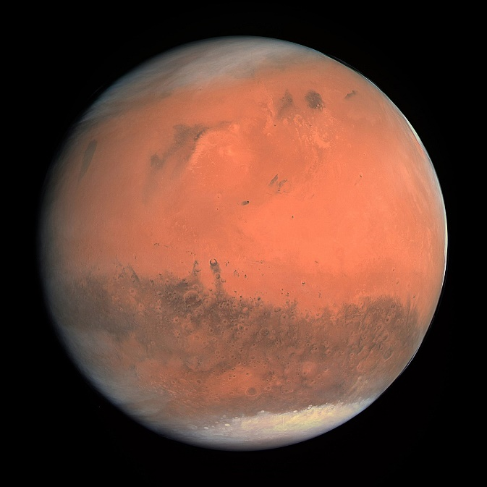
1.Earth
2.Mars
3.Jupiter
4.Saturn
5.Uranus
6.Neptune

Mars is the 4th planet from the sun and is the second smallest planet in the solar system.

Mars is also named after the Roman god of war. Mars is also described as the “Red planet”.
I would like to visit this planet because the days and seasons are the same as earth.

Lucie year 4

