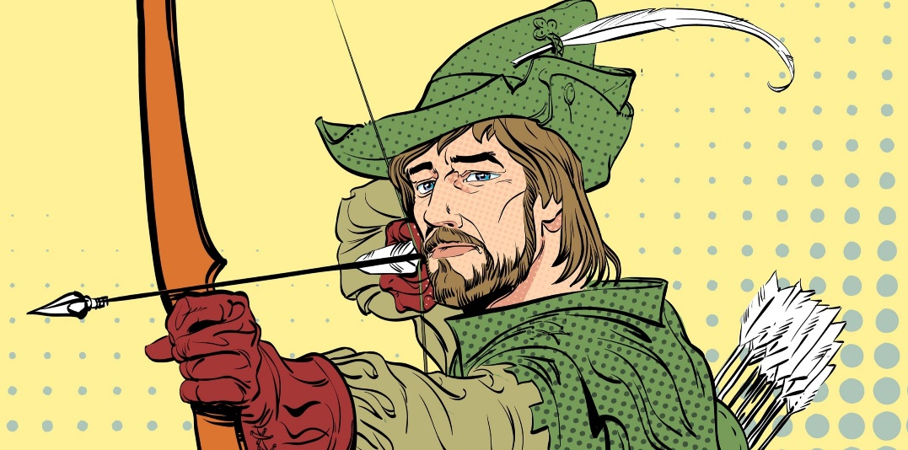
Robin Hood and Little John
They’d passed the graveyard on the edge of the village by the light of a full moon, and the hoot of an owl signalled their passage. They spent the next few hours trudging through the gloom of the forest on their way back to Nottingham. Mist hung about the ground at knee height, giving the forest an ethereal feel. Robin’s friend, Will, turned to him and confessed quietly he wasn’t happy about the uncomfortable silence which enveloped the woods. Usually, even at such an early hour, the woods were filled with noises, but tonight all was deathly silent.

They reached the river crossing just after dawn had broken and found a sun-dappled space to sit, eat and rest a while before crossing the water into the part of the forest inhabited by outlaws. Robin stood and stretched before retrieving his pack, his quiver and his bow. “Come on!” he said to Will, who lay napping on the heather and he nudged him with the toe of his boot. “How much longer is it?” said Will screwing up his face and shielding his eyes from the low hanging sun, “we’ve been walking all night!”
“Not much further,” said Robin, “but keep your wits about you now…you never know who is lurking in the woods on the Wester’ side.”

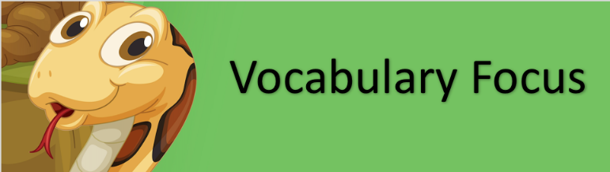

- Use a dictionary to find the word ‘ethereal’ can you write a definition for it in your own words?
- What do you think the word ‘enveloped’ means?
- Which word in the text tells you that outlaws lived in the forest?
- Outlaw is a compound word made of two smaller words. What do you think it means?
- What does the word trudging tell us about the way the two of them move through the forest?
- Which word in the second paragraph means someone is ‘lying in wait?’
Robin Hood and Little John
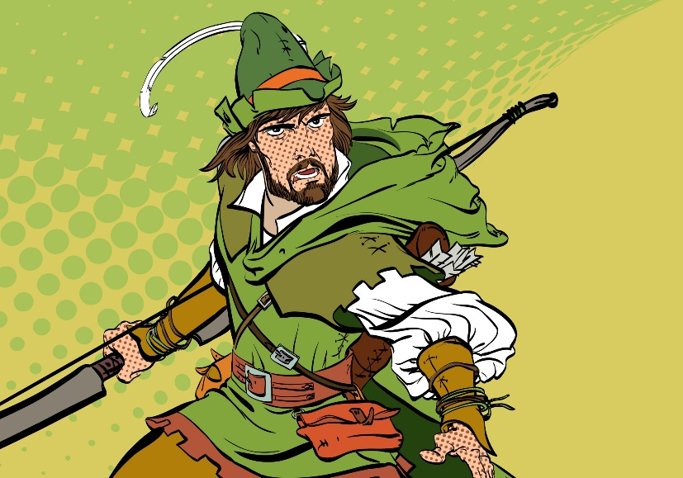
Robin had only taken a few steps onto the bridge when there was a flurry of movement at the other end. Either side of the bridge, men with bows erupted from the foliage; their arrows aimed at Robin and Will. One of the men started to cross the bridge towards them. The man was one of the tallest that they had ever seen. He was a whole head taller than Robin. He carried a long staff as thick as a man’s wrist and he was grinning from ear to ear - flashing his teeth at the two weary travellers. “Look sharp!” Robin hissed at Will.

“Bridge tax!” the tall man bellowed, “stand where you are!” The two of them continued to edge further forwards until Robin was standing face to face with the brigand. “You cannot come across this bridge without paying the fee!”
With unnatural speed, Robin had pulled an arrow from his quiver, nocked it and was now stood with his drawn bow pointing in the giant’s bearded face. “Now, now…” said the Giant taking a step backwards, “there is no need for that.” Robin took half a step towards the bandit who suddenly swung his staff violently, knocking Robin’s bow into the river; sending his arrow flying off to embed itself into the trunk of a nearby by tree.
The outlaw laughed, “if you want to fight rather than pay, then it needs to be a fair fight.” he said as he handed Robin another staff. “If you can knock me, Little John, from the bridge then I will waive the fee.”
Robin let out a deep sigh as he hefted the staff. ‘Little John?’ he thought to himself, ‘the man is as big as a bull and twice as fierce!’

R | How far onto the bridge was Robin when John appeared?
V | Which words show that the men appeared quickly?
E | Explain how you know that this story is set in the past.
I | What is Robin thinking/feeling when he ‘let out a ‘deep sigh?’
S | How does Little John earn money?

