Dr. Martin Luther King Jr’s life
Martin Luther King Jr. was born on January 15th, 1929 in Atlanta, Georgia
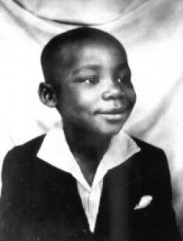
At birth he was called Michael King Jr. after his father. When did his name change? Michael’s dad was a Christian minister and his faith was very important to him. In 1934 his dad went to Germany for an important religious meeting. The trip inspired his dad greatly and one of the hero Christians, a man named Martin Luther was the inspiration behind the name change. His dad and young Michael king Jr. names were swapped to Martin Luther King Jr.
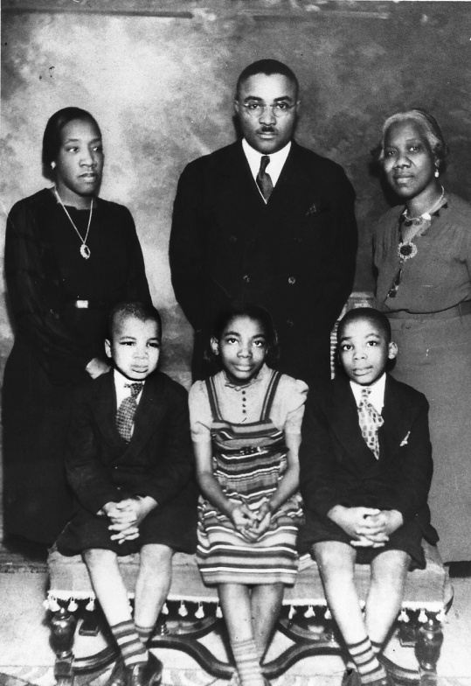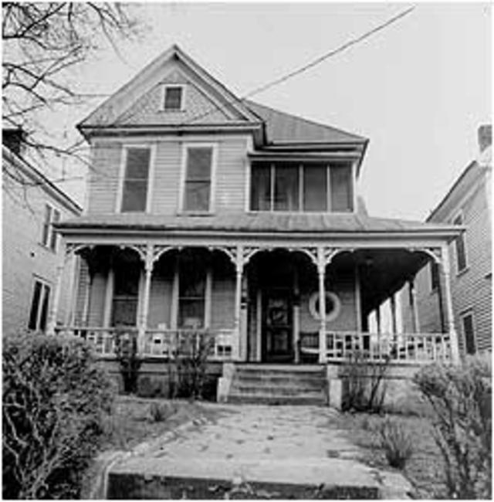
His family His House as a kid

As a teenager, Martin attended Booker T. Washington High school. He was known for being a gifted speaker and was part of the school’s debate team. He was so gifted that he won a speech contest in Dublin, Georgia. But on his way back to Atlanta he was forced to stand up during the bus ride just because he was an African-American,
He later said it was the most angriest he’d ever been.

After high school martin continued his education at More-house College. He finally got his Doctorate at Boston University. He studied to be a minister and he was now called Dr. Martin Luther King Jr. but let’s call him Dr. King.
He then had his own family marrying Coretta Scott and had had four kids.
Dr. King led marches and protests and proved change can happen without violence.
Dr. King was arrested 29 times while fighting for equality!
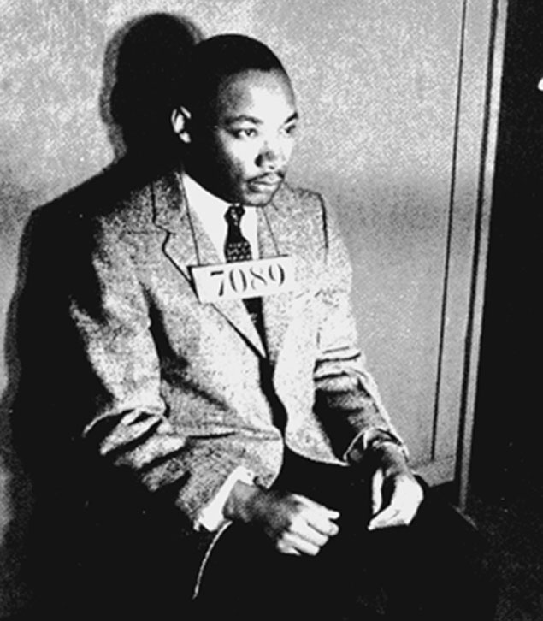
In 1963 he gave his best speech called ‘I have a dream’ and more than 250,000 people turned up! In 1964 the civil rights acts was signed then just after that he received the Nobel peace prize, becoming the youngest winner ever (he was only 35 years old) but on April 4th 1968 while staying in Lorraine motel in Memphis, TN. Dr. Martin Luther King Jr. was shot and sadly killed by someone trying to stop his message. But Dr. King’s message could not be stopped…

