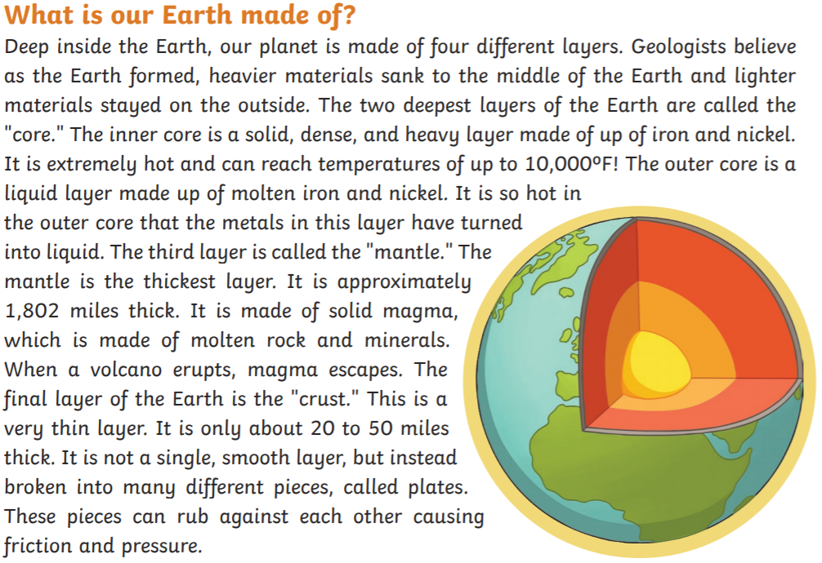
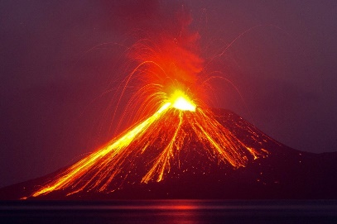

1. Our planet is made up of four different layers. Can you name all of them? (4)
2. What is the inner core made up of? (2)
3. What is the thickest layer and how think is the layer? (2)
4. Solid magma is a mixture of two materials, what are the two materials? (2)
5. What is the final layer of the Earth? (1)

