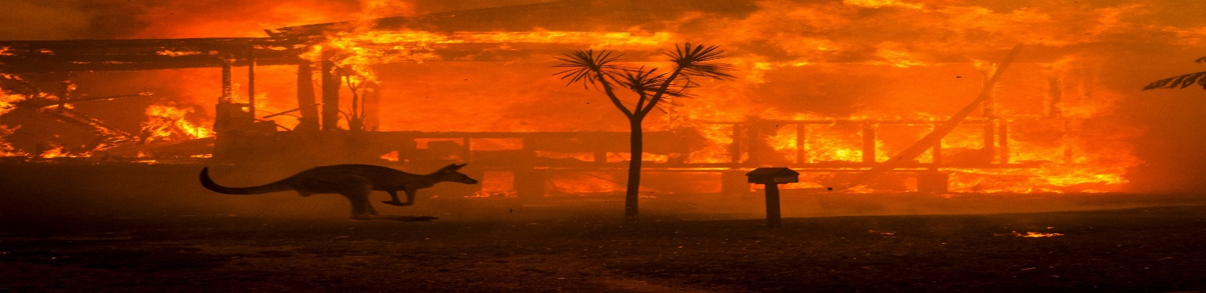
Australia fires: A visual guide to the bushfire crisis.

Record-breaking temperatures and months of severe drought have fuelled a series of massive bushfires across Australia.
Although recent cooler conditions and rain have brought some respite, more than 50 fires are still burning in the states of New South Wales and Victoria.

Hot and windy conditions are forecast to return to many parts of New South Wales this weekend and authorities in the Australian Capital Territory (ACT) have declared a state of emergency as massive bushfires rage south of Canberra.

At least 33 people have been killed - including four firefighters - and more than 11 million hectares (110,000 sq km or 27.2 million acres) of bush, forest and parks across Australia has burned.

New South Wales and Victoria have been worst affected
In the worst-hit state, New South Wales (NSW), fire has affected more than five million hectares, destroying more than 2,000 houses and forcing thousands to seek shelter elsewhere. More than 1,600 firefighters are currently working to slow the spread of fires and dig up containment lines, the NSW Rural Fire Service says.
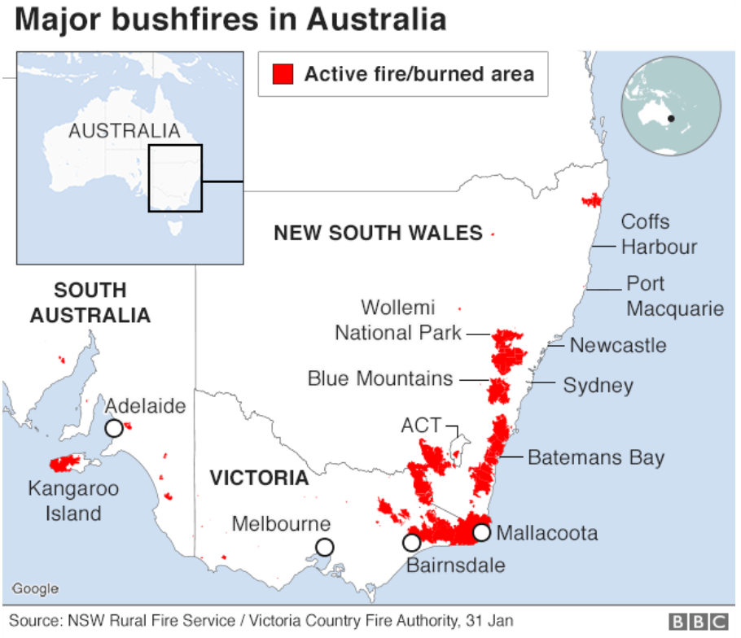

The fires have been worse than usual
Although Australia has always had bushfires, this season has been worse than usual.
The amount of land affected across the country - more than 10 million hectares - is now comparable to England's land area of 13 million hectares. That’s nearly the size of the UK! Imagine the whole of the UK on fire!
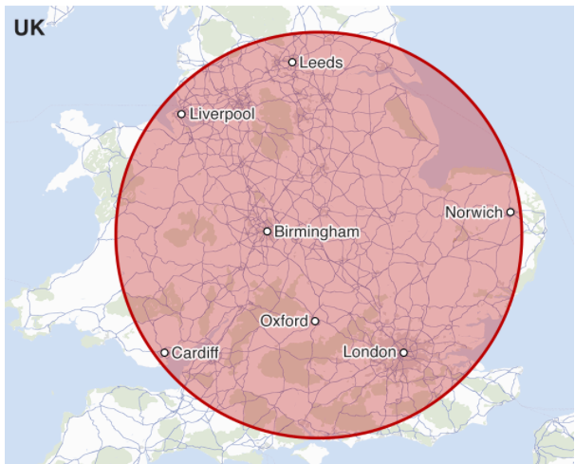

So, is this down to climate change?
Many Australians are asking that very question - but the science is complicated.
Scientists have long warned that a hotter, drier climate will contribute to fires becoming more frequent and more intense. Many parts of Australia have been in drought conditions, some for years, which has made it easier for the fires to spread and grow.
Data shows that Australia has warmed overall by slightly more than one degree Celsius since 1910, with most of the heating occurring since 1950.

