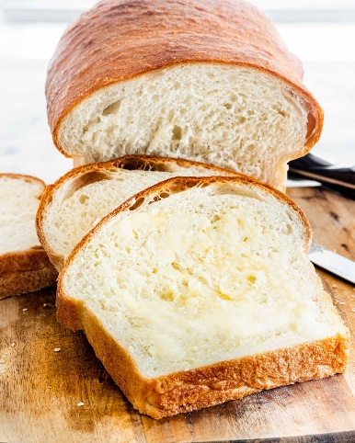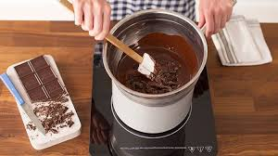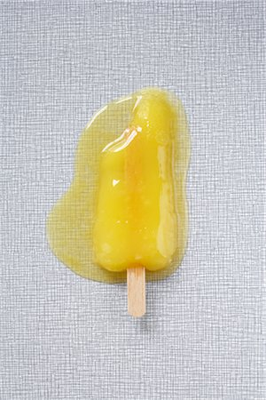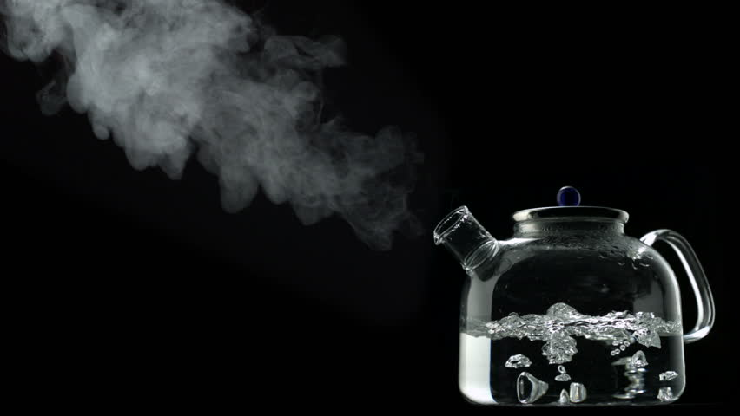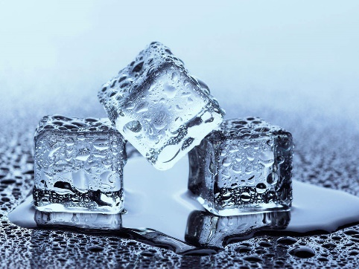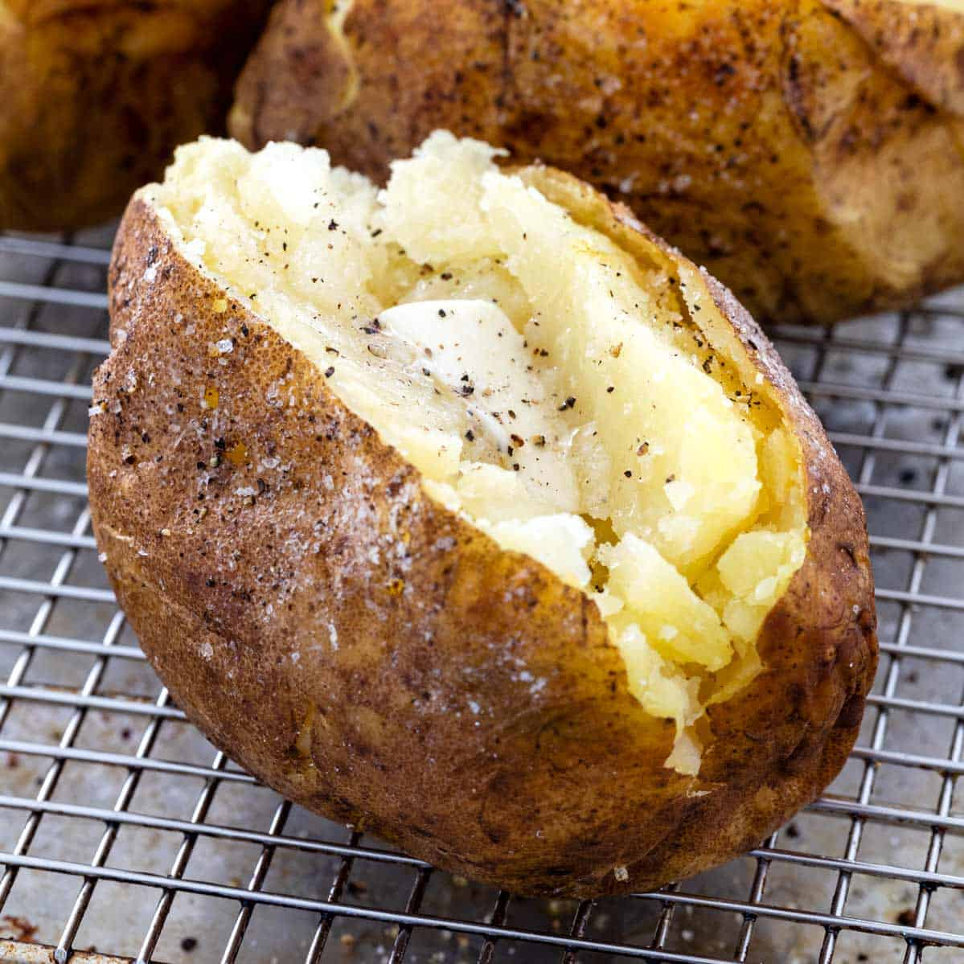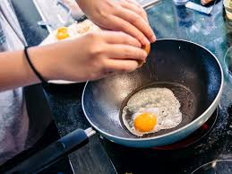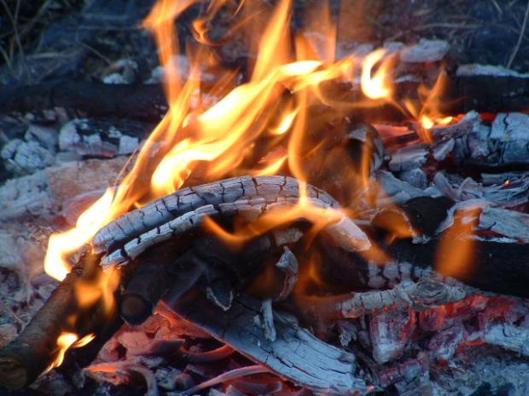

Baking Bread

Melting chocolate

Melting Lolly

**Reversible and Irreversible changes!**

**Can you sort these items into the table below?**

Freezing Water

Cooking an Egg

Baking a potato

Boiling water

Burning wood

|  |  |
| --- | --- |
| **Irreversible** | **Reversible** |
|  |  |