So far this week we have been learning about the 4 quarters of the clock face. We have had a look at o’clock, quarter past, half past and quarter to. Today, we are going to look at estimating and reading time with increased accuracy.
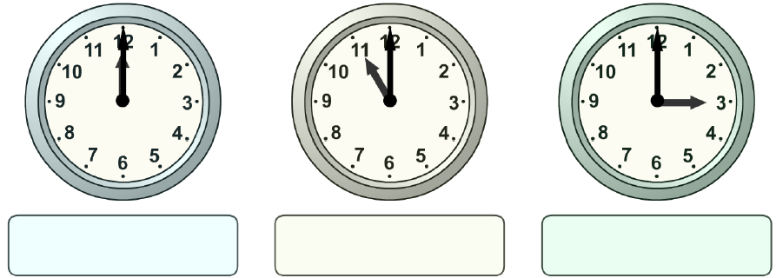
1. On the clocks below, can you tell me what time it will be in an hour and a half?

2. On the clocks below, can you tell me what time it will be in an hour and 15 minutes?
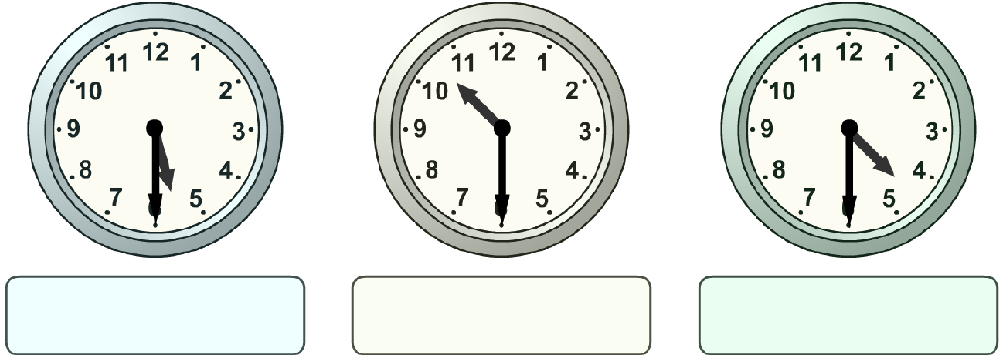

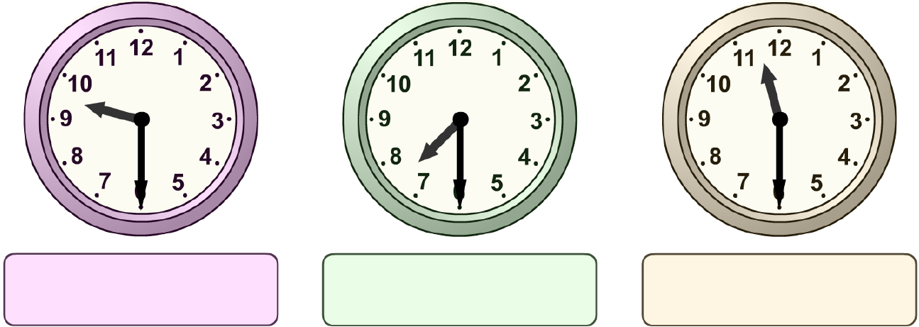
3. On the clocks below, can you tell me what time it will be in an hour and 45 minutes?

Time worded problems
Have a go at the time related worded problems below.
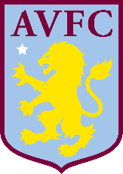
1. Mr Crouch goes to an Aston Villa football match at 3 o’clock, the football match finishes after an hour and a half. What time does the football match finish at?

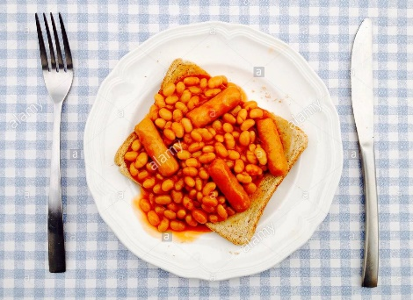
2. Mr Swallow started cooking a meal for his girlfriend at half past one. It took him one hour to cook the meal. What time did Mr Swallow finish cooking at?

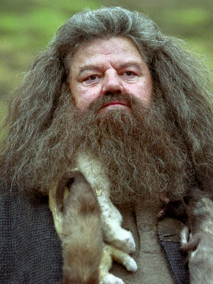
3. Miss Housley straightened her curly hair for a night out. She started straightening her hair at half past six. It took Miss Housley one hour and 45 minutes to straighten her hair. At what time was Miss Housley’s hair straight?

