The Tube Map
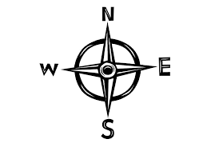
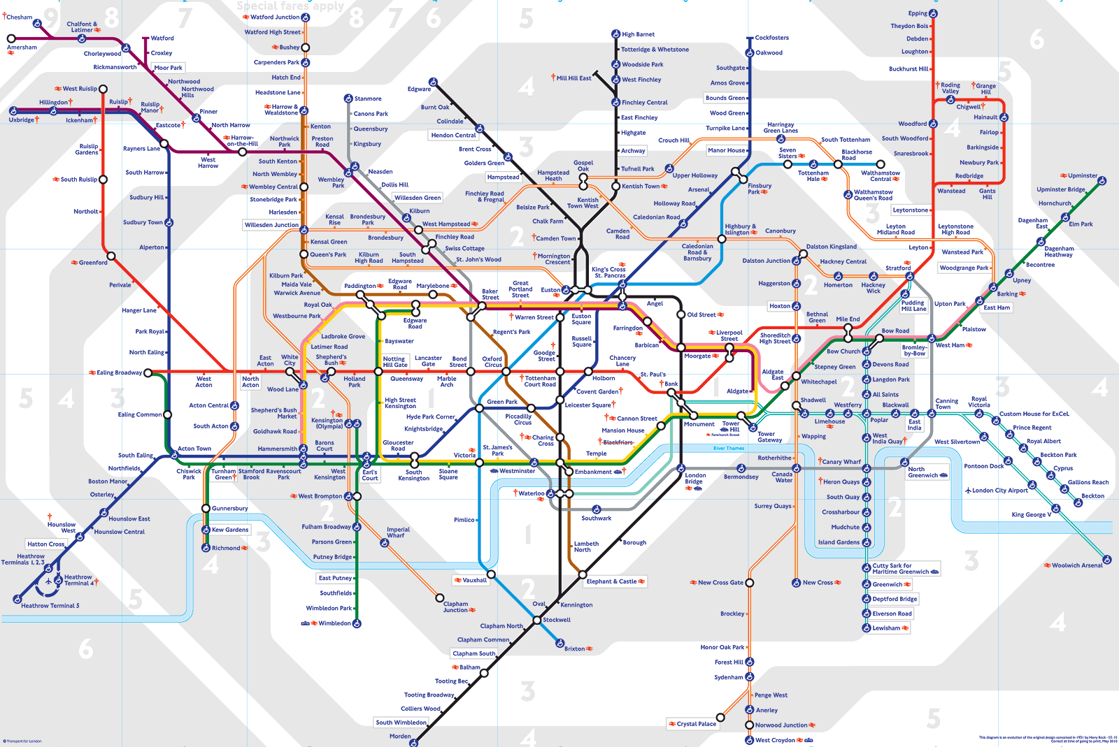

- Can you find the red Central Line? It runs right through the centre of London so it is pretty well named! It goes from the top, left corner of the map at West Ruislip to Eping at the top right corner. That means to travel from West Ruislip to Eping, you are travelling EAST. Follow the journey with your finger.

- Now, can you tell me the station you would end up at if you got on at the following stations and travelled to the end of the line…
- Get on the Northern line at Edgware and travel all the way south.
- Get on the Victoria line at Walthamstow Central and travel all the way south
- Get on the Bakerloo line at Elephant & Castle and travel all of the way North.

- Ok, let’s try something more difficult. Now I will give you a station that is part way along a line and tell you how many stops you travel!
  - Get on the Central Line at Marble Arch and travel 3 stops TO THE WEST.
  - Get on the Circle Line at Bayswater and travel 2 stops TO THE SOUTH.
  - Get on the District Line at Embankment and travel WEST. Which stop is after South Kensington?

- Wait a minute! Have you managed to do all of that already? You are obviously some kind of London Underground expert! Ok, you must be up for a challenge. When you see a junction like this, it means you can swap from one line to another. Here you can see that at Tottenham Court Road station, you could swap from the Central Line to the Northern Line.

I would like you to plan a journey for me, to get me from Epping to Woolwich Arsenal. Tell me which lines to use, which direction to travel and how many stops on each before you change lines!

